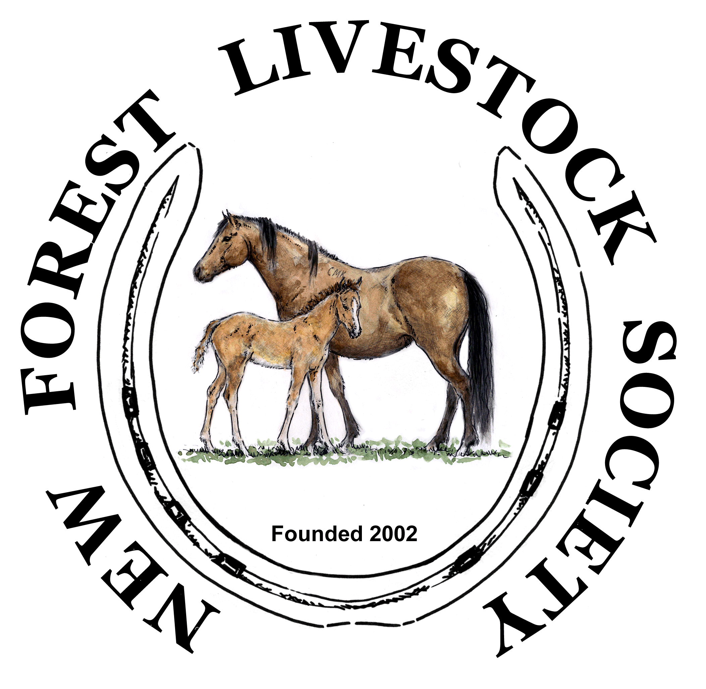
New Forest Livestock Society
Beaulieu Road Pony Sales
2023 Buyer’s Guide

This guide will take you through how the auction process works with some useful tips if you should successfully purchase an animal/s at the sales.
Before the Sale and Suitable Transport
All prospective purchasers should carefully read the Conditions of Sale and Special Conditions of Sale in the catalogue.
It is important that you ensure you have suitable trailer / lorry transport. Trailers require top doors to be fully functional (or jump bars) and are secured after loading.
Most of the animals will be semi-feral, it is important to read the Transport Regulations guidelines how to travel and maximum per trailer / lorry partition.
It is recommended, if you are using hired transport, to contact transporters and get quotes prior to the sale to agree costs and ensure animal/s will be collected on the day.
Day of Sale
On the day of the sale, you will need to complete a buyer’s registration form from the onsite Auctioneers office where you will then be allocated a number to use when bidding. If you are successful in buying an animal/s your number will be used for processing and payment.
Bidding is in now in GBP pounds and all lots are sold without VAT unless stated at the point of sale by the auctioneer when the vendor is VAT registered. All lots, at the fall of the hammer, become the liability of the purchaser and at their risk. There is a buyer’s premium to be added on to the purchase price (currently 6% including VAT) – see the Auctioneers conditions of sale for more details.
It is the purchaser’s responsibility to have prior transport arrangements in place to collect their purchases from the sale yard on the day of the sale. If prior arrangements have been made for your ponies to go into lairage, cost of collection from the saleyard and any ‘keep’ costs until transported to the new owner’s home are the responsibility of the purchaser and these should have been agreed with whoever is providing the lairage.
You have made a successful purchase, what next?
You can pay for your animal/s throughout the day at the Auctioneers onsite office in cash, debit card or Bank Transfer payment. The Auctioneers will issue you with appropriate paperwork including a Pass Out document to be handed to the officials at the loading bay confirming your purchase.
Before collecting your animal/s, you need to visit the New Forest Pony Breeding and Cattle Society onsite office to make appropriate transfers into your ownership (please visit the NFPBCS website for transfer costs). The NFPBCS will provide you with your passport with ownership updated.
All purchasers are advised to check the description of their lots in the passport before leaving the sale yard. Ponies are deemed to be signed out of the Food Chain unless stated otherwise at the point of sale.
Loading
Once you have paid for your ponies and collected your passports please make your way, with your transport, to the loading area of the sale yard. Officials will direct you accordingly. Once you are in position, hand your Pass Out document to one of the New Forest Livestock Society officials who will locate your animal/s and bring down for loading. No unauthorised individuals are to enter the sale yard. Please note NFLS officials will not put headcollars onto animals, this will need to be done when you get home.
When you get home
It is recommended that you worm your animal/s once back home and establish a regular worming treatment programme. This should be done after your animal/s have settled into their new environment.
Be thoughtful with regards to feeding. Most semi-feral animals will not know what ‘hard’ food is so it is important not to overfeed which may cause problems.
Many of the semi-feral animals will not have been handled so consideration should be given regarding immediate stabling until they are settled into their new environment.

Useful Links and Contact Details:

New Forest Livestock Society https://www.nfls.org.uk/
Southern Counties Auctioneers https://www.scauctioneers.com/Sales/Sale-Types-and-Locations/Beaulieu-Road-Pony-Sales
New Forest Pony Breeding & Cattle Society https://www.newforestpony.com/

